**Head Sketch Survey**

When people are taught to sketch faces, they are told to place the eyes at the midline of the head like this:

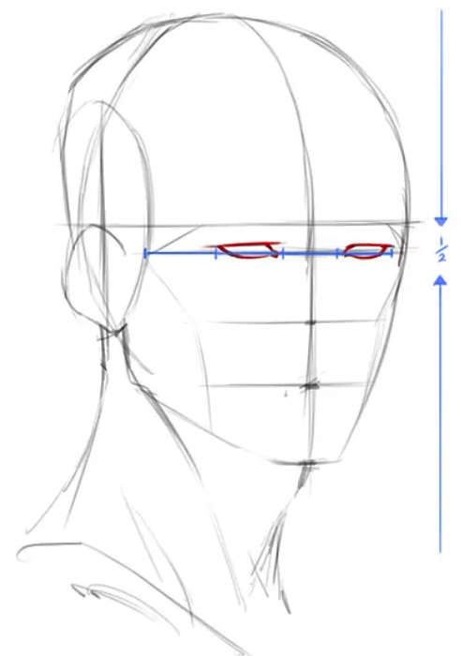

This sometimes strikes people as wrong because they think the eyes are slightly above the midline of the head.

1. Before actually measuring your head, what you do you think? Circle the option that best fits your opinion.
   1. I think my eyes are basically at the midline of my head.
   2. I think my eyes are above the midline of my head.
   3. I think my eyes are below the midline of my head.
2. Self-Measurements: Now measure the length of your head and calculate where midline would be. Also measure where your eyes are in relation to the midline. Write your measurements in boxes below.

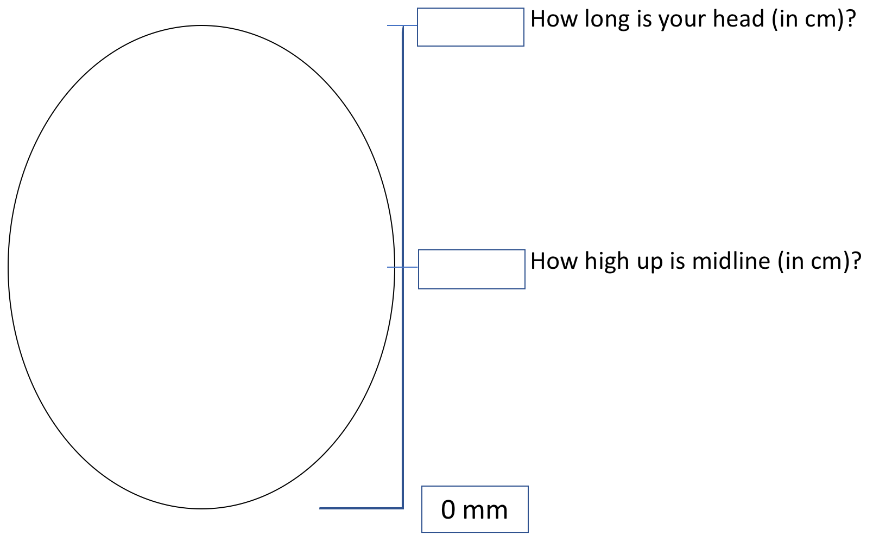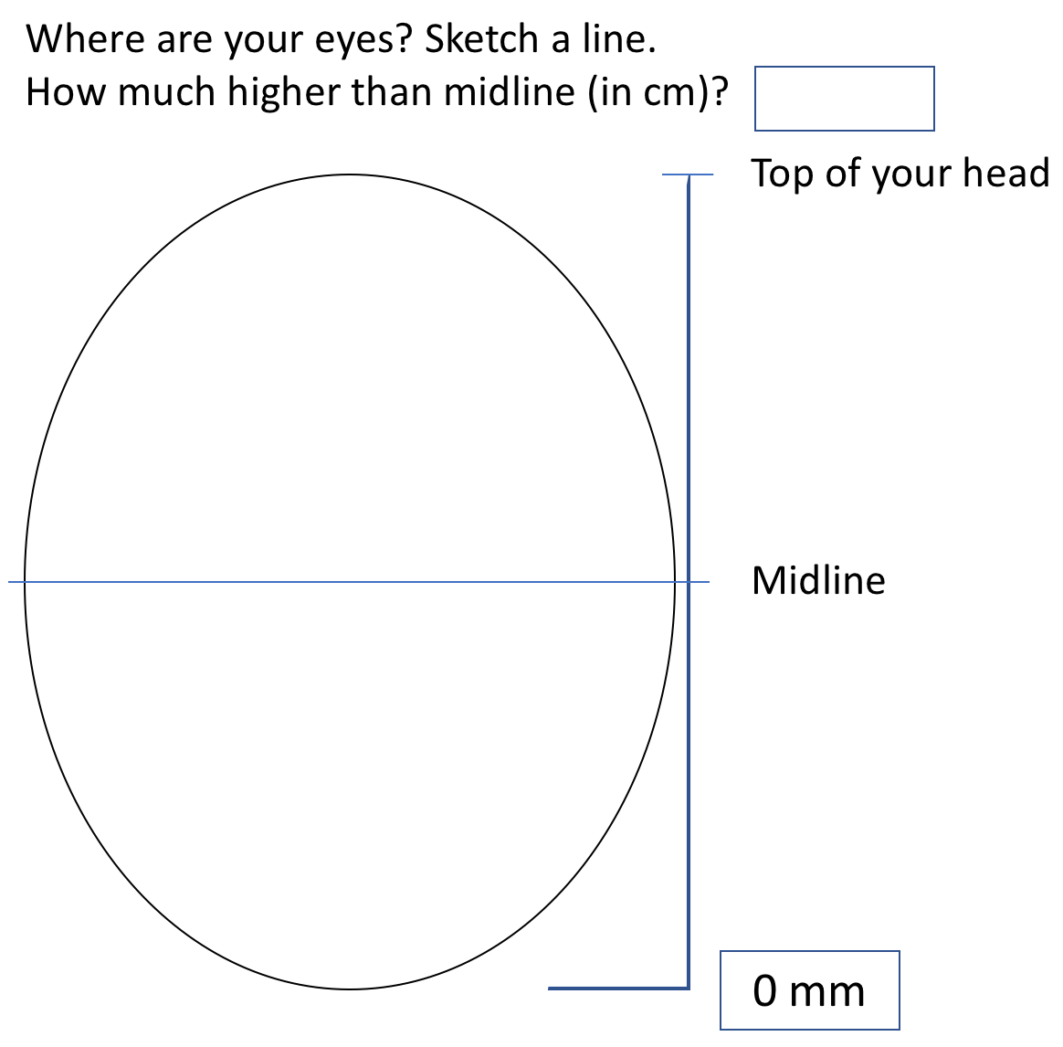

1. Get together with a partner. Don’t show them your measurements. **Silently** let them measure you. Fill these out with THEIR measurements of YOUR face. Try to keep a poker face. Take turns.

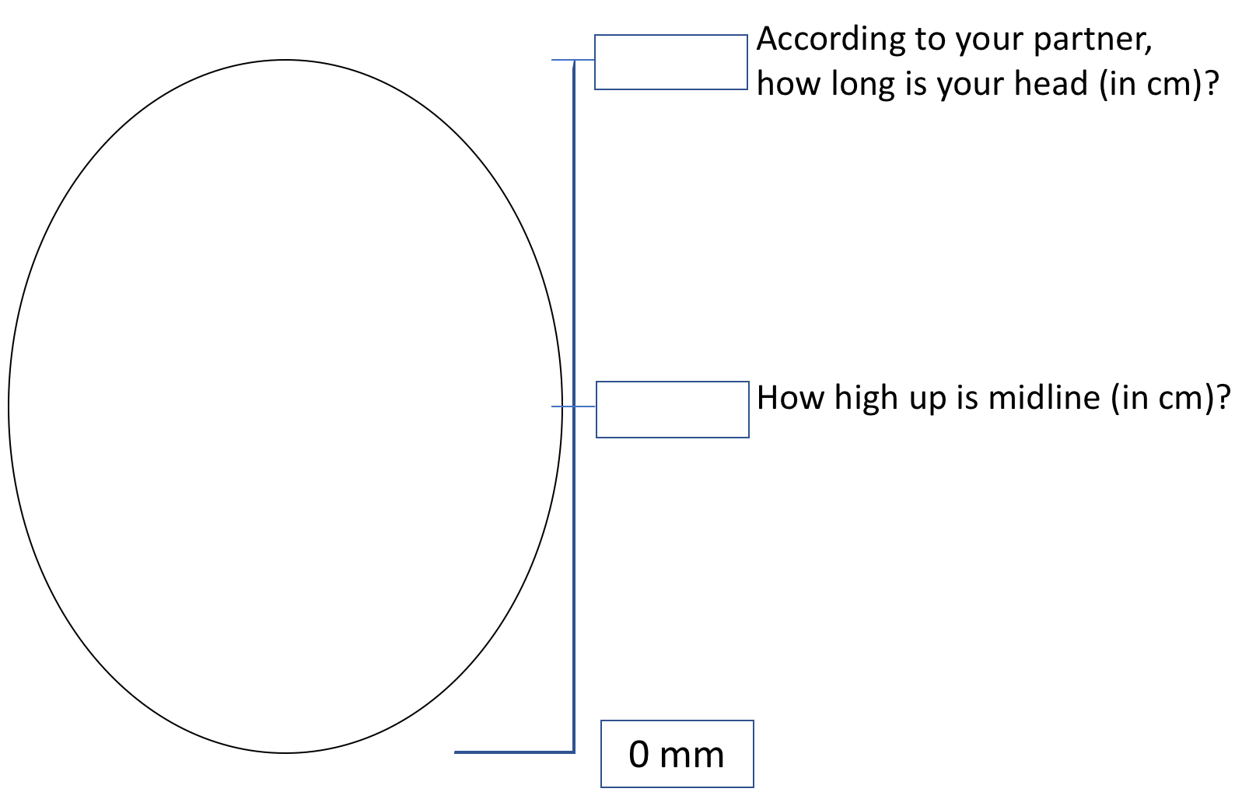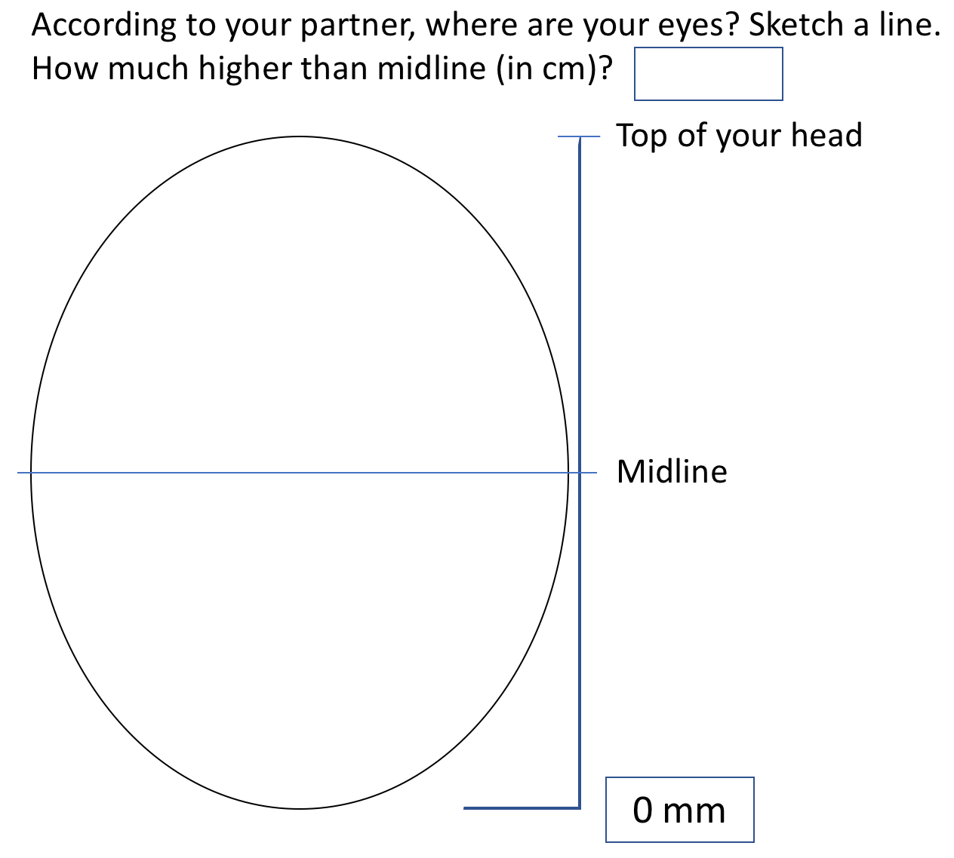

1. Based on your measurements (in question 2), are your eyes on the midline?
   1. My eyes are basically at the midline of my head.
   2. My eyes are above the midline of my head.
   3. My eyes are below the midline of my head.
2. Based on your partner’s measurements (in question 3), are your eyes on the midline?
   1. My eyes are basically at the midline of my head.
   2. My eyes are above the midline of my head.
   3. My eyes are below the midline of my head.
3. Which part of the eye did you use to measure where your eye was in relation to your head?
4. How tall are you (in cm)? Feel free to either use the provided ruler or convert from inches to cm with a calculator (1 inch = 2.54 cm)